**Dynamic Functional Connectivity**

A tutorial

# 1 Introduction

This document was prepared on 2021-02-15.

# 2 Fig 1

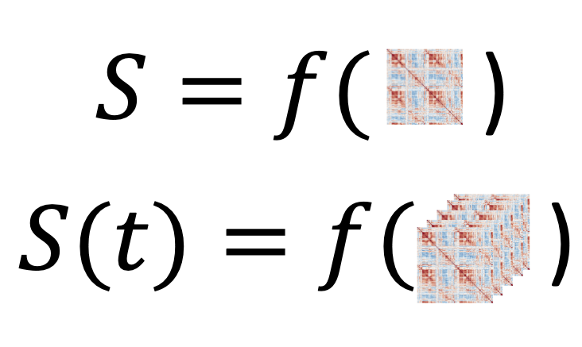

# 3 Fig 2



Adapted from: <https://en.wikipedia.org/wiki/Voxel#/media/File:Voxels.svg>

# 4 Fig 3



# 5 Fig 4

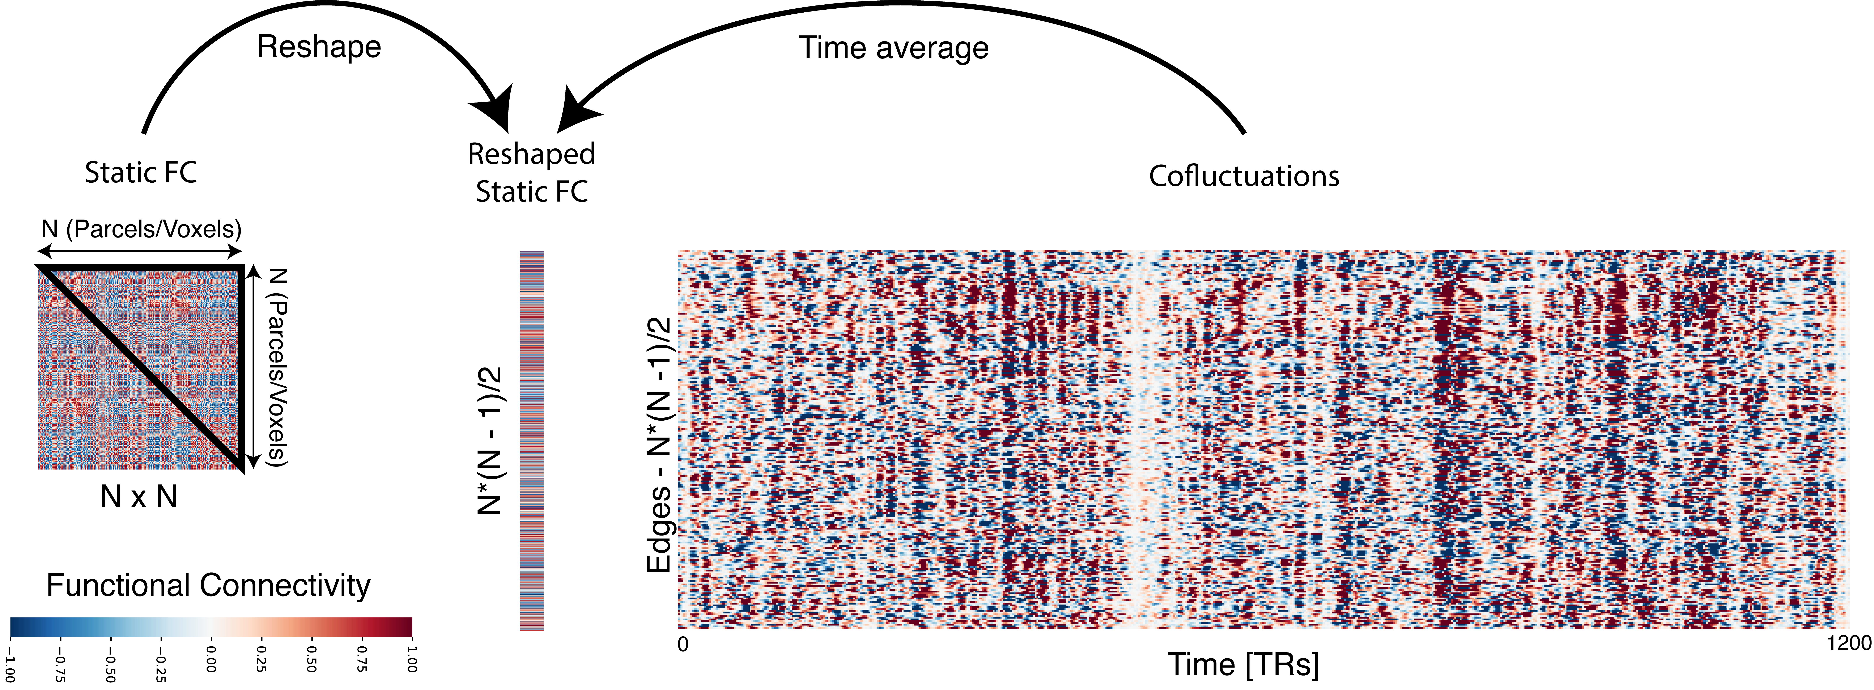

# 6 Fig 5



# 7 Fig 6

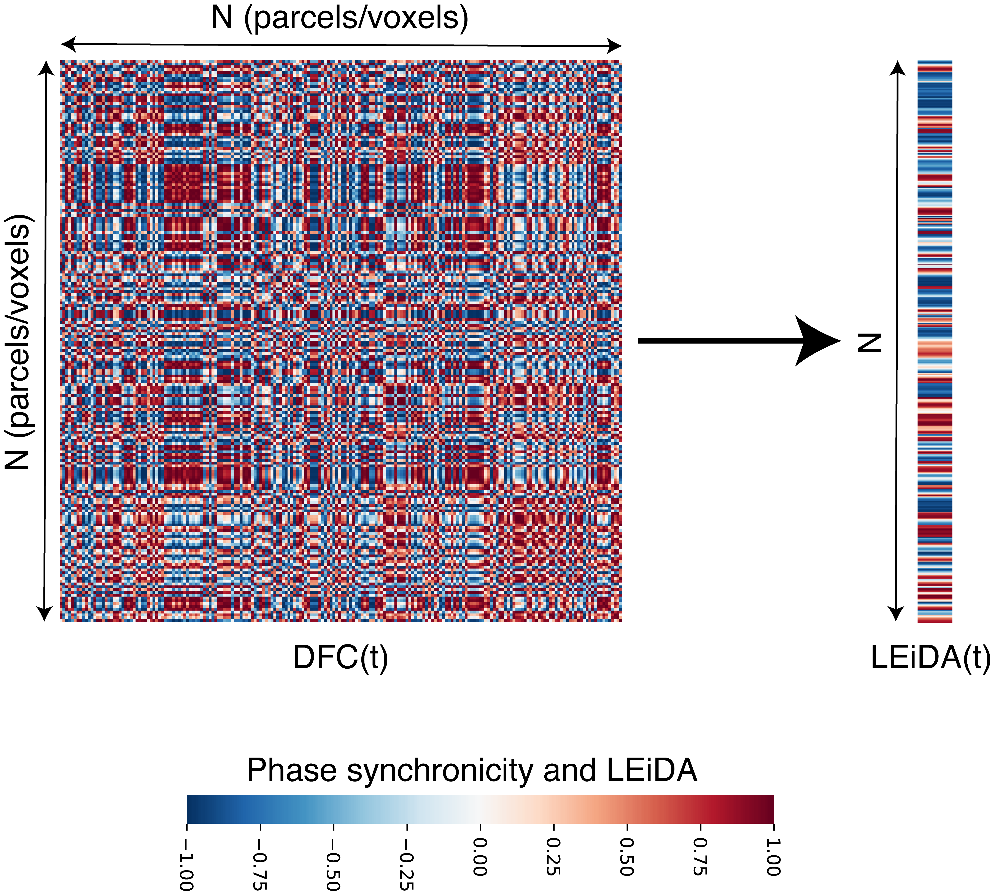

# 8 Fig 7

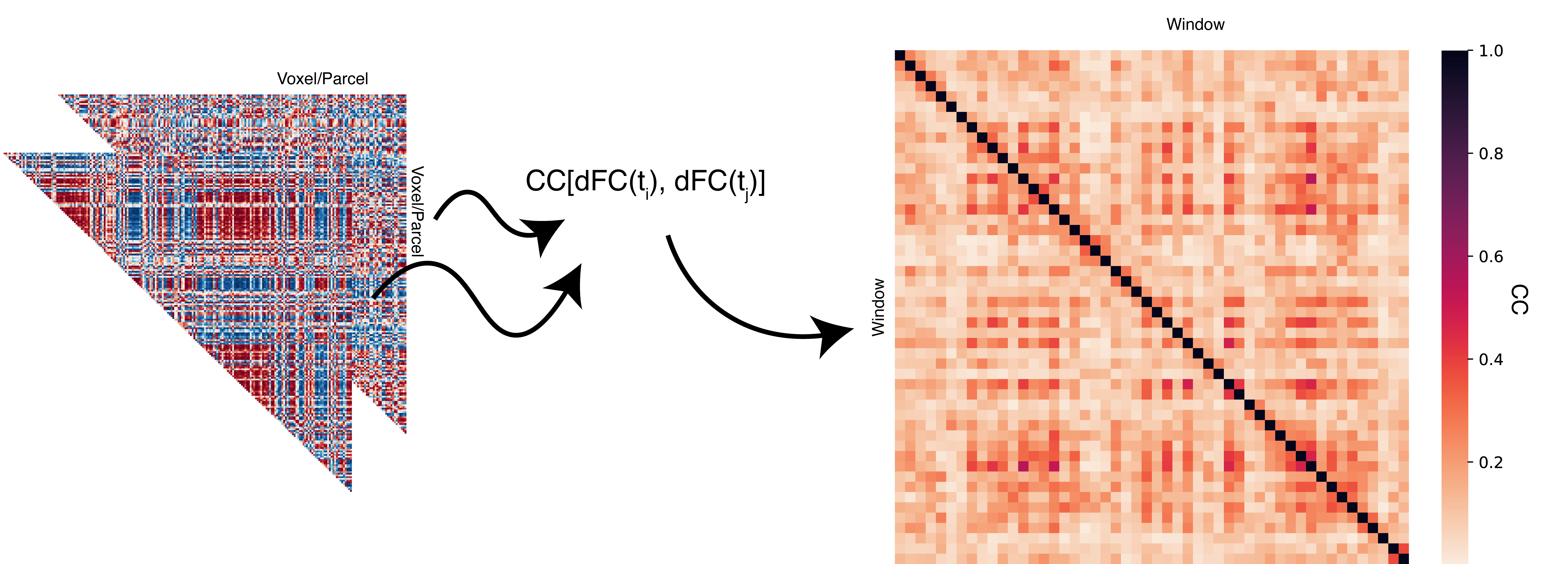

# 9 Sliding windows

import sys  
sys.path.insert(1, 'libs/')  
  
import dynfc as dyn  
import numpy as np  
from numpy.random import seed, rand  
import scipy as sc  
from scipy import io  
import seaborn as sns  
import matplotlib.pyplot as plt  
import matplotlib.cbook as cbook  
import matplotlib.cm as cm  
import matplotlib.patches as patches  
  
font = {'weight' : 'regular',  
 'size' : 24}  
plt.rc('font', **font)  
  
ts = sc.io.loadmat('data/ts.mat')['ts']  
ts = ts.transpose()  
  
corr_mats, idx = dyn.corr_slide(ts,300,50)  
  
idx.shape

> (24,)

a = [1,1,1,1,1.6]  
  
fig,ax = plt.subplots(1)  
fig.set_figheight(10)  
fig.set_figwidth(20)  
plt.style.use('tableau-colorblind10')  
for i in range(5):  
   
 plt.plot(2*i*a[i] + ts[i,]/1.4)

> [<matplotlib.lines.Line2D object at 0x7f9aea98beb8>]  
> [<matplotlib.lines.Line2D object at 0x7f9ab244ad68>]  
> [<matplotlib.lines.Line2D object at 0x7f9ab26c8a58>]  
> [<matplotlib.lines.Line2D object at 0x7f9aead7ffd0>]  
> [<matplotlib.lines.Line2D object at 0x7f9ab244af60>]

plt.xlabel('Time [TRs]')

> Text(0.5, 0, 'Time [TRs]')

plt.ylabel('BOLD')

> Text(0, 0.5, 'BOLD')

ax.tick_params(left=False)  
ax.set_yticklabels([])

> [Text(0, -2.0, ''), Text(0, 0.0, ''), Text(0, 2.0, ''), Text(0, 4.0, ''), Text(0, 6.0, ''), Text(0, 8.0, ''), Text(0, 10.0, ''), Text(0, 12.0, ''), Text(0, 14.0, '')]

ax.set_ylim(-3,15.4)

> (-3.0, 15.4)

ax.set_xlim(0,1200)

> (0.0, 1200.0)

rect = patches.Rectangle((idx[0],-2.8),300,18,linewidth=4,edgecolor='#595959',facecolor='none')  
ax.add_patch(rect)

> <matplotlib.patches.Rectangle object at 0x7f9ab24302e8>

rect = patches.Rectangle((idx[5],-2.8),300,18,linewidth=4,edgecolor='#A56B6B',facecolor='none')  
ax.add_patch(rect)

> <matplotlib.patches.Rectangle object at 0x7f9ab2430a90>

rect = patches.Rectangle((idx[9],-2.8),300,18,linewidth=4,edgecolor='#CE3E3E',facecolor='none')  
ax.add_patch(rect)

> <matplotlib.patches.Rectangle object at 0x7f9ab2445080>

rect = patches.Rectangle((idx[16],-2.8),300,18,linewidth=4,edgecolor='#FF0000',facecolor='none')  
ax.add_patch(rect)

> <matplotlib.patches.Rectangle object at 0x7f9b0d2189b0>

plt.show()



> (0.0, 200.0, 200.0, 0.0)



> (0.0, 200.0, 200.0, 0.0)



> (0.0, 200.0, 200.0, 0.0)



> (0.0, 200.0, 200.0, 0.0)



# 10 Cofluctuations

import sys  
sys.path.insert(1, 'libs/')  
  
import numpy as np  
import scipy as sc  
from scipy import io  
import dynfc as dyn  
import seaborn as sns  
import matplotlib.pyplot as plt  
  
ts = sc.io.loadmat('data/ts.mat')['ts']  
ts = ts.transpose()  
  
mat1, rss = dyn.corr_slide(ts,24)  
mat1 = mat1[:,:,0]  
  
aa = plt.figure(figsize = [6,6])  
ax = sns.heatmap(mat1,   
 cmap = "RdBu_r",   
 vmin = -1,   
 vmax = 1,   
 square = False,   
 cbar = True)  
ax.axis('off')

> (0.0, 200.0, 200.0, 0.0)

ax.tick_params(left=False, bottom=False)  
plt.show()



upt = np.triu_indices(mat1.shape[0], k = 1)  
vec = (mat1[upt])  
  
toPlot = np.zeros((vec.shape[0],1))  
toPlot[:,0] = vec  
  
aa = plt.figure(figsize = (12/50,4))  
ax = sns.heatmap(toPlot[:,0:1],   
 cmap = "RdBu_r",   
 vmin = -1,   
 vmax = 1,   
 square = False,   
 cbar = False)  
ax.axis('off')

> (0.0, 1.0, 19900.0, 0.0)

plt.show()



edges_series, corr_mats, rss = dyn.cofluct(ts, 24)  
  
aa = plt.figure(figsize = (12,4))

> /Users/runner/Library/r-miniconda/envs/r-reticulate/bin/python:1: RuntimeWarning: More than 20 figures have been opened. Figures created through the pyplot interface (`matplotlib.pyplot.figure`) are retained until explicitly closed and may consume too much memory. (To control this warning, see the rcParam `figure.max_open_warning`).

ax = sns.heatmap(edges_series,   
 cmap = "RdBu_r",   
 vmin = -1,   
 vmax = 1,   
 square = False,   
 cbar = False)  
ax.axis('off')

> (0.0, 1200.0, 19900.0, 0.0)

plt.show()



#Phase difference

import sys  
sys.path.insert(1, 'libs/')  
  
import numpy as np  
import matplotlib.pyplot as plt  
import matplotlib.patches as patches  
from mpl_toolkits.mplot3d import Axes3D  
  
theta = np.linspace(0*np.pi, 8*np.pi, 100)  
time = np.linspace(0, 8, 100)  
y1 = np.sin(theta)  
x1 = np.cos(theta)  
y2 = np.sin(theta + np.pi/2)  
x2 = np.cos(theta + np.pi/2)  
r = time/np.max(time)  
ones = np.ones(time.shape[0])  
  
fig = plt.figure()  
ax = fig.add_subplot(projection='3d')  
plt.style.use('classic')  
  
ax.plot(time, x1, y1, color = '#67001f', linewidth=2)

> [<mpl_toolkits.mplot3d.art3d.Line3D object at 0x7f9bdc8eb128>]

ax.plot(time,ones,y1, linestyle = '--', color = '#0f0f0f')

> [<mpl_toolkits.mplot3d.art3d.Line3D object at 0x7f9bdc90eac8>]

ax.plot(time,x1,-ones, linestyle = '--', color = '#0f0f0f')

> [<mpl_toolkits.mplot3d.art3d.Line3D object at 0x7f9bdc90e278>]

ax.quiver(time,0,0,0, 0.99*x1, 0.99*y1,   
 length = 0.9,   
 normalize = False,   
 arrow_length_ratio = 0.1,   
 alpha = 0.4,   
 color = '#053061')

> <mpl_toolkits.mplot3d.art3d.Line3DCollection object at 0x7f9bdc90ea20>

ax.text(0.5, 1, 0.5, r'$\sin(\theta)$', fontsize = 20)

> Text(0.5, 1, '$\\sin(\\theta)$')

ax.text(0.5, -1, -1, r'$\cos(\theta)$', fontsize = 20)

> Text(0.5, -1, '$\\cos(\\theta)$')

ax.set_xlabel('Time')

> Text(0.5, 0, 'Time')

ax.set_ylabel('Re')

> Text(0.5, 0, 'Re')

ax.set_zlabel('Im')

> Text(0.5, 0, 'Im')

ax.set_xlim(0,8)

> (0.0, 8.0)

ax.set_ylim(-1,1)

> (-1.0, 1.0)

ax.set_zlim(-1,1)

> (-1.0, 1.0)

plt.show()



colors1 = plt.cm.Reds(np.arange(0,1,0.01))  
colors1[:,-1] = np.arange(0,1,0.01)  
  
colors2 = plt.cm.Blues(np.arange(0,1,0.01))  
colors2[:,-1] = np.arange(0,1,0.01)  
  
fig = plt.figure(figsize = (12,8))  
ax = fig.add_subplot(projection='3d')  
plt.style.use('classic')  
  
ax.scatter(time,ones,r*y1, color = colors1, marker = ",", s = 3)

> <mpl_toolkits.mplot3d.art3d.Path3DCollection object at 0x7f9bdc9897b8>

ax.scatter(time,r*x1,-ones, color = colors1, marker = ",", s = 3)

> <mpl_toolkits.mplot3d.art3d.Path3DCollection object at 0x7f9bdc989780>

ax.scatter(time,ones,r*y2, color = colors2, marker = ",", s = 3)

> <mpl_toolkits.mplot3d.art3d.Path3DCollection object at 0x7f9bdc905d30>

ax.scatter(time,r*x2,-ones, color = colors2, marker = ",", s = 3)  
#ax.plot(time,r*x2,-ones, linestyle = '--', color = colors2[-10,:])

> <mpl_toolkits.mplot3d.art3d.Path3DCollection object at 0x7f9bdc905630>

ax.quiver(time,0,0,0, 0.99*r*x1, 0.99*r*y1,   
 length = 0.9,   
 normalize = False,   
 arrow_length_ratio = 0.1,   
 alpha = 1,   
 color = colors1)

> <mpl_toolkits.mplot3d.art3d.Line3DCollection object at 0x7f9bdc905c18>

ax.quiver(time,0,0,0, 0.99*r*x2, 0.99*r*y2,   
 length = 0.9,   
 normalize = False,   
 arrow_length_ratio = 0.1,   
 alpha = 1,   
 color = colors2)

> <mpl_toolkits.mplot3d.art3d.Line3DCollection object at 0x7f9bdc905c50>

ax.text(0.5, 1, 0.4, r'$A(t)$ $\sin(\theta)$', fontsize = 20)

> Text(0.5, 1, '$A(t)$ $\\sin(\\theta)$')

ax.text(0.5, -0.9, -1, r'$A(t)$ $\cos(\theta)$', fontsize = 20)

> Text(0.5, -0.9, '$A(t)$ $\\cos(\\theta)$')

ax.set_xlabel('Time')

> Text(0.5, 0, 'Time')

ax.set_ylabel('Re')

> Text(0.5, 0, 'Re')

ax.set_zlabel('Im')

> Text(0.5, 0, 'Im')

ax.set_xlim(0,8)

> (0.0, 8.0)

ax.set_ylim(-1,1)

> (-1.0, 1.0)

ax.set_zlim(-1,1)

> (-1.0, 1.0)

plt.show()



x1_vec = x1  
x1_vec = x1_vec[99]  
y1_vec = y1  
y1_vec = y1_vec[99]  
  
x2_vec = x2  
x2_vec = x2_vec[99]  
y2_vec = y2  
y2_vec = y2_vec[99]  
  
x, y = 0.0, 0.0  
  
fig,ax = plt.subplots(1)  
fig.set_figheight(6)  
fig.set_figwidth(7)  
ax.scatter(r*x1,r*y1, color = colors1, marker = ".", s = 100)

> <matplotlib.collections.PathCollection object at 0x7f9bdc9a7f98>

ax.scatter(r*x2,r*y2, color = colors2, marker = ".", s = 100)

> <matplotlib.collections.PathCollection object at 0x7f9bdc980f98>

ax.arrow(0,0,x1_vec,y1_vec, width = 0.015, color = colors1[-1,:], head_width = 0.1)

> <matplotlib.patches.FancyArrow object at 0x7f9bdc905cf8>

ax.arrow(0,0,x2_vec,y2_vec, width = 0.015, color = colors2[-1,:], head_width = 0.1)

> <matplotlib.patches.FancyArrow object at 0x7f9bde39ac88>

ax.add_patch(patches.Arc((x,y), 2.3, 2.3, theta1=0.0, theta2=90.0, linestyle = '--'))

> <matplotlib.patches.Arc object at 0x7f9bdc980ba8>

ax.text(0.7,1, r'$\mathcal{\Delta\varphi = \frac{\pi}{2}}$', fontsize = 24)

> Text(0.7, 1, '$\\mathcal{\\Delta\\varphi = \\frac{\\pi}{2}}$')

ax.text(1.18*x1_vec,y1_vec, r'$\mathcal{\varphi}_{1}$', fontsize = 20)

> Text(1.18, -9.797174393178826e-16, '$\\mathcal{\\varphi}_{1}$')

ax.text(x2_vec,1.22*y2_vec, r'$\mathcal{\varphi}_{2}$', fontsize = 20)

> Text(-7.354070601250002e-16, 1.22, '$\\mathcal{\\varphi}_{2}$')

ax.set_xlim(-1.35,1.35)

> (-1.35, 1.35)

ax.set_ylim(-1.35,1.35)

> (-1.35, 1.35)

ax.set_xlabel('Re')

> Text(0.5, 0, 'Re')

ax.set_ylabel('Im')

> Text(0, 0.5, 'Im')

plt.show()



import sys  
sys.path.insert(1, 'libs/')  
  
import numpy as np  
import scipy as sc  
from scipy import io  
import dynfc as dyn  
import seaborn as sns  
import matplotlib.pyplot as plt  
  
ts = sc.io.loadmat('data/ts.mat')['ts']  
ts = ts  
  
RSsig = np.zeros((ts.shape[0],ts.shape[1],1))  
RSsig[:,:,0] = ts  
  
Phases, syncConn, leidaArray = dyn.run_multiPat(RSsig)

> Signal filtered.  
> Phases obtained.  
> Matrices obtained.  
> Routine finished for patient no. 1.

mat1 = syncConn[:,:,0,0]  
  
aa = plt.figure(figsize = [7,6])  
ax = sns.heatmap(mat1,   
 cmap = "RdBu_r",   
 vmin = -1,   
 vmax = 1,   
 square = True,   
 cbar = True)  
ax.axis('off')

> (0.0, 200.0, 200.0, 0.0)

ax.tick_params(left=False, bottom=False)  
plt.show()



aa = plt.figure(figsize = (12/50,4))  
ax = sns.heatmap(leidaArray[:,0,]/max(abs(leidaArray[:,0,])),   
 cmap = "RdBu_r",   
 vmin = -1,   
 vmax = 1,   
 square = False,   
 cbar = False)  
ax.axis('off')

> (0.0, 1.0, 1180.0, 0.0)

plt.show()



# 11 Package References

report::cite_packages(sessionInfo())

* JJ Allaire and Yihui Xie and Jonathan McPherson and Javier Luraschi and Kevin Ushey and Aron Atkins and Hadley Wickham and Joe Cheng and Winston Chang and Richard Iannone (2020). rmarkdown: Dynamic Documents for R. R package version 2.6. URL <https://rmarkdown.rstudio.com>.
* Kevin Ushey, JJ Allaire and Yuan Tang (2021). reticulate: Interface to ‘Python’. R package version 1.18-9007. <https://github.com/rstudio/reticulate>
* R Core Team (2020). R: A language and environment for statistical computing. R Foundation for Statistical Computing, Vienna, Austria. URL <https://www.R-project.org/>.